

Experiment No 9: Depth First Search and Breadth First Search

Aim: Depth First Search and Breadth First Search

Objective:
- To gain a comprehensive understanding of DFS and BFS as essential techniques for exploring and analyzing graphs.
- To implement DFS and BFS algorithms in a programming environment to traverse and manipulate graph data structures.
- To compare and contrast the characteristics, advantages, and disadvantages of DFS and BFS when applied to different types of graphs and specific problem scenarios.

Theory:
In this experiment, participants will gain a deep understanding of DFS and BFS, their applications, and their differences. They will implement these algorithms, analyze their time and space complexities, and learn when to choose one over the other based on problem requirements and graph characteristics. The experiment will also provide hands-on experience with graph representations and the practical application of these traversal algorithms.
Algorithm :
Initialize the required variables:

n: The number of vertices in the graph.
i, j: Loop counters.
visited[10]: An array to keep track of visited vertices.
queue[10]: An array acting as a queue for BFS traversal.
front: Initialize the front of the queue to -1.
rear: Initialize the rear of the queue to -1.
adj[10][10]: A 2D array representing the adjacency matrix of the graph.
Define the bfs function with parameter v (the starting vertex):
a. Iterate through all vertices from 1 to n:

If there is an edge between vertex v and vertex i, and vertex i has not been visited (!visited[i]), add vertex i to the queue.
b. If the queue is not empty (front <= rear), perform the following:
Mark the vertex at the front of the queue as visited (visited[queue[front]] = 1).
Increment front to dequeue the front vertex.
Recursively call the bfs function with the new front vertex.
In the main function:
a. Read the number of vertices n from the user.
b. Initialize the queue and visited arrays.
c. Read the adjacency matrix of the graph from the user.
d. Read the starting vertex v for BFS traversal.
e. Call the bfs function with the starting vertex v.

After completing the BFS traversal, print the reachable nodes:
a. Iterate through all vertices from 1 to n:

If a vertex is marked as visited (visited[i]), print it as a reachable node.
If no vertex is marked as visited after the BFS traversal, print a message indicating that BFS is not possible because not all nodes are reachable.
End the program.

Code :
#include <stdio.h>

int n, i, j, visited[10], queue[10], front = -1, rear = -1;
int adj[10][10];

void bfs(int v)
{
for (i = 1; i <= n; i++)
if (adj[v][i] && !visited[i])
queue[++rear] = i;
if (front <= rear)
{
visited[queue[front]] = 1;
bfs(queue[front++]);
}
}

void main()
{
int v;
printf("Enter the number of vertices: ");
scanf("%d", &n);
for (i = 1; i <= n; i++)
{
queue[i] = 0;
visited[i] = 0;
}
printf("Enter graph data in matrix form: \n");
for (i = 1; i <= n; i++)
for (j = 1; j <= n; j++)
scanf("%d", &adj[i][j]);
printf("Enter the starting vertex: ");
scanf("%d", &v);
bfs(v);
printf("The node which are reachable are: \n");
for (i = 1; i <= n; i++)
if (visited[i])
printf("%d\t", i);
else
printf("BFS is not possible. Not all nodes are reachable");
return 0;
}

Output :
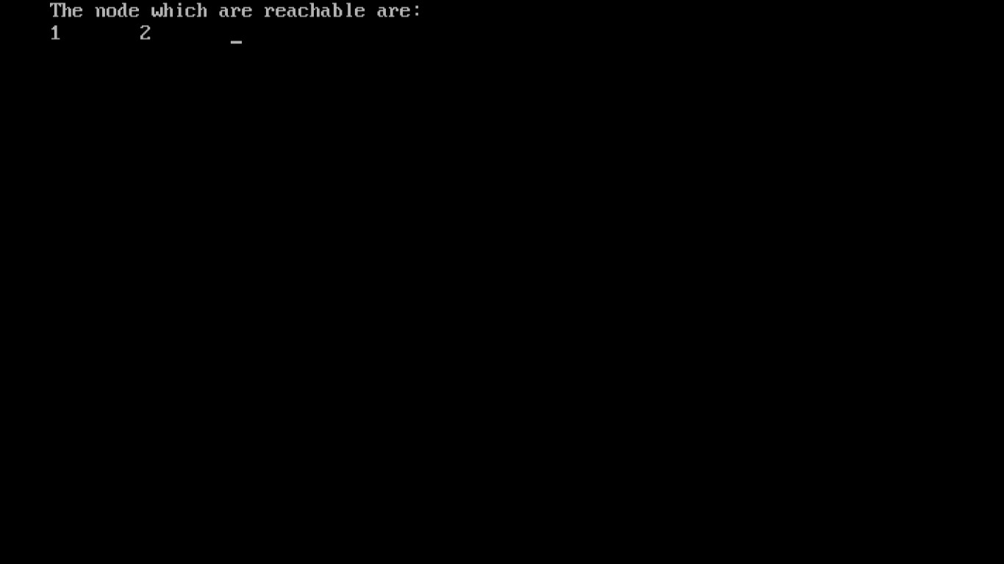

Conclusion :
In conclusion, the BFS and DFS experiment not only equipped participants with the knowledge and skills to work with these essential graph traversal algorithms but also enhanced their problem-solving abilities and algorithmic thinking. These skills have broad applications in computer science and various industries, making the experiment a valuable learning experience.

